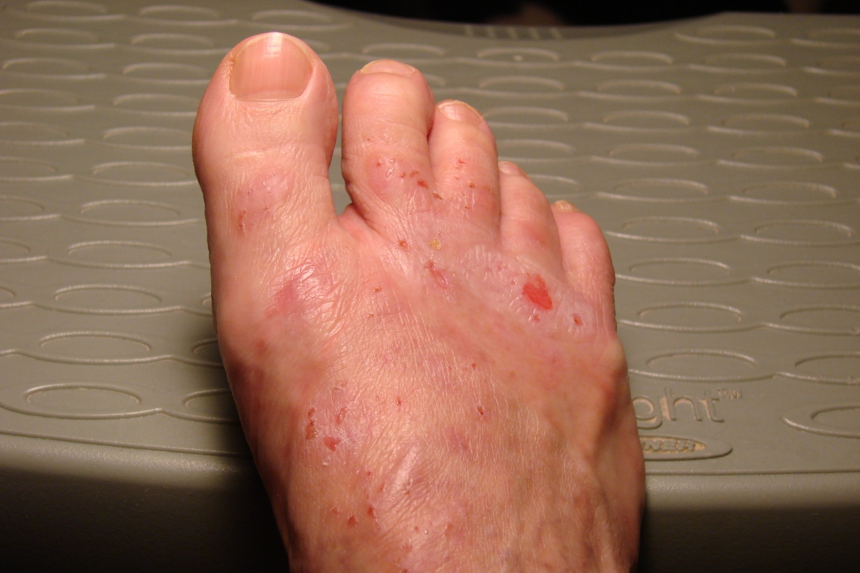

After using the Cansema® Deep tissue black salve (multiple times over weeks for about 10-15 minutes per application) most problem areas on my foot scabbed over. About five areas drained pink to yellow pus and all areas felt much better than before the treatments. The area that had previously itched intensely (even though no lesion was present-see arrow) ruptured and drained large amounts of grainy yellow stuff. I used the Cansema® again since the itching and dark specks returned.

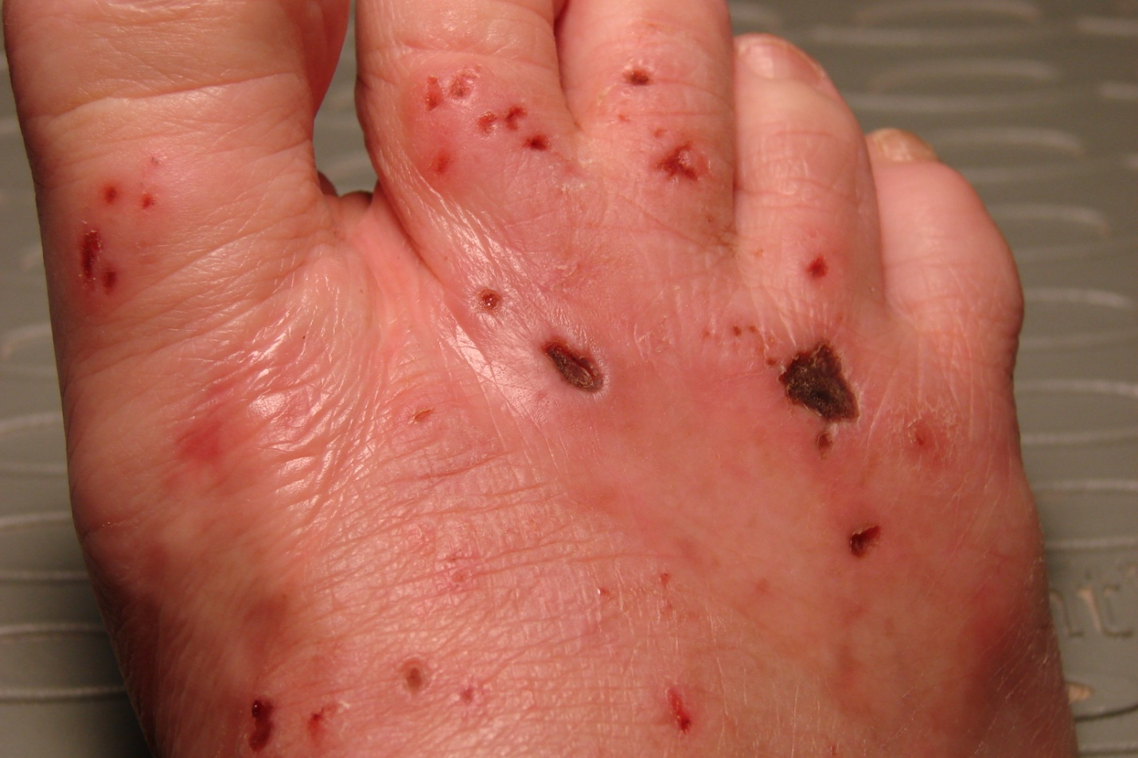That spot scabbed over and appeared to contain a large glob of something – I am not sure what! I have never seen anything like it before.

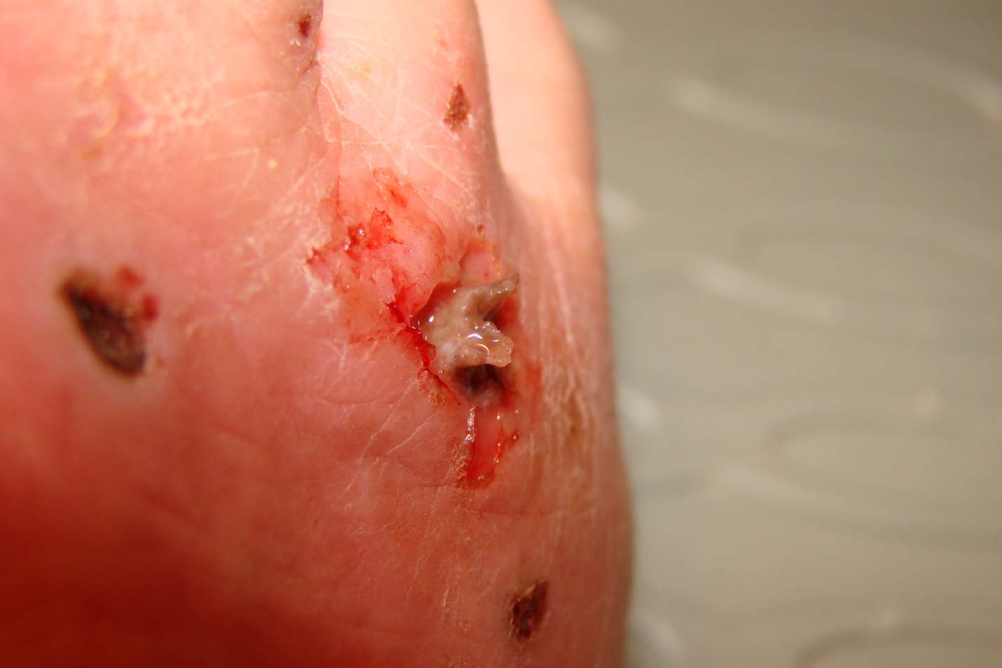

This “glob” was removed with extreme difficulty and yellow grainy pus drained from beneath the area.

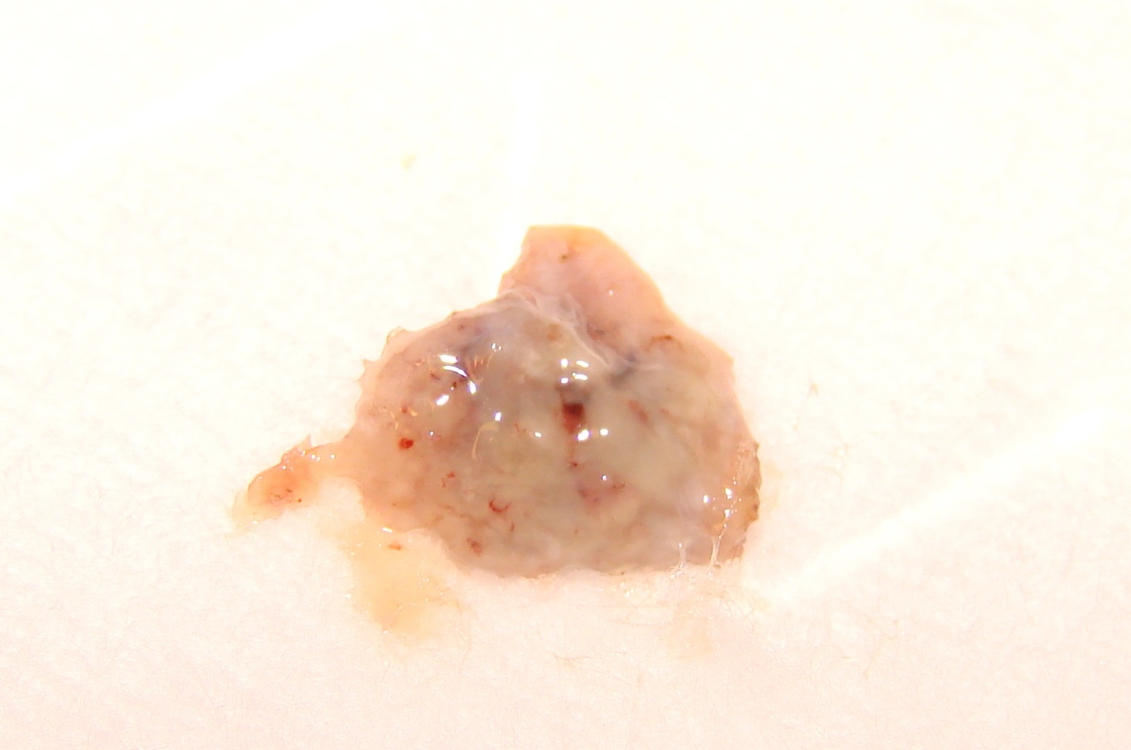

This is a picture of the “thing” I removed. It almost looks like a solidified gel of some sort. Has anyone seen something similar?